1. If I find Covariance between same variable what will be the output? What will be Correlation coefficient?

**Answer:**

Covariance is calculated between two different variables. The output between the same variables will be ZERO. The Correlation coefficient will also be ZERO

1. Assume I have a set of numbers. The mean, median and mode of the set of numbers areequal. If I draw a Frequency plot of individual distinct numbers, how would the plot looklike?

|  |  |  |
| --- | --- | --- |
| A | B | C |

**Answer: B**

1. If the scores for a given sample distribution are: 32 32 35 36 37 38 38 39 39 39 40 40 42 45, Find the Variance and The Standard Deviation

**Answer:**

Since its sample distribution and not population distribution, the formula used is

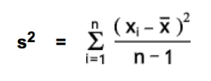

|  |  |  |  |
| --- | --- | --- | --- |
|  | *X* | *(X-Average)* | *(X-Average)^2* |
| X1 | 32 | -6 | 36 |
| X2 | 32 | -6 | 36 |
| X3 | 35 | -3 | 9 |
| X4 | 36 | -2 | 4 |
| X5 | 37 | -1 | 1 |
| X6 | 38 | 0 | 0 |
| X7 | 38 | 0 | 0 |
| X8 | 39 | 1 | 1 |
| X9 | 39 | 1 | 1 |
| X10 | 39 | 1 | 1 |
| X11 | 40 | 2 | 4 |
| X12 | 40 | 2 | 4 |
| X13 | 42 | 4 | 16 |
| X14 | 45 | 7 | 49 |
| **Average** | **38** |  |  |
| **Total** |  |  | **162** |
| **S^2 - Sample Variance** | **12.46** |  |  |
| **Standard Deviation** | **3.53** |  |  |

|  |  |
| --- | --- |
| **USING EXCEL FORMULA** | |
| S^2 - Sample Variance | 11.57 |
| Standard Deviation | 3.40 |

1. The following table shows percent variations of two financial indices, the NYSE (New YorkStock Exchange ) and the NASDAQ composite (National Association of Securities DealersAutomated Quotation) in 10 consecutive days:

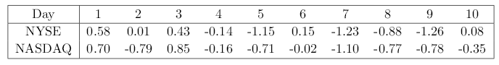

Use a suitable measure to quantify the dependence between the variations of the two indices and comment on the result

**Answer:**

The suitable measure is CORRELATION CO-EFFICIENT. (Since the magnitude of COVARIANCE is not easy to measure). There is NO CORRELATION between the two